**CS 245: Object-Oriented Programming**

FaceDraw Mostly-In-Class Assignment – 10 points

Due Wednesday, October 18 at 6pm.

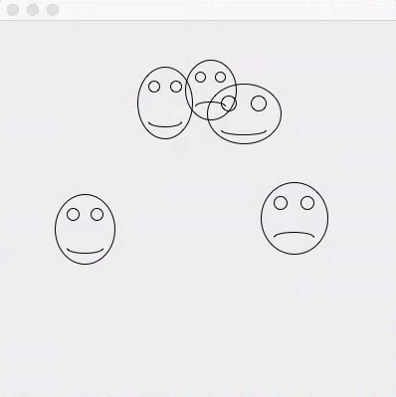

For this assignment, you will create an application in Java that draws random faces on a window. The application will draw anywhere from 3 to 10 random faces each time it is run. The faces will have a random width and height, with those widths and heights set to reasonable ranges so that the faces have dimensions typical of a face. Each face is to have two eyes and a mouth. The mouth may be smiling, frowning, or in-between, and that is chosen randomly.

Here is how your program will be graded:

|  |  |
| --- | --- |
| Requirement | Points |
| The Face class is the model class. It has data members that store the width, height, x, y, and smile status. It also has constructors, get and set functions, and a toString function. | 1 |
| Your main function creates and randomly populates a list of Face objects. The Face objects are created with random width, top, left, height, and smile status. | 1 |
| You have a view class that descends from JFrame called FaceFrame. It has one component within it: a JPanel descendant object of type FacePanel that will be used to hold the FaceObjects. | 1 |
| Your main function creates the FaceFrame object, passing to it the list of Face objects. The FaceFrame, in turn, creates its FacePanel, passing to FacePanel’s constructor the list of Face objects so that it has access to them to draw them. | 1 |
| The FacePanel’s paintComponent function actually draws the Face objects where they are supposed to be and how they are supposed to look. | 1 |
| Your code is heavily commented with Javadoc comments to demonstrate to me that you know how the various pieces work and why we included them. | 5 |

Turn in your .java files, loaded with javadoc comments, as a single .zip file with the name LastNameFaceDraw.zip by 6pm Wednesday, October 18.

We will not have class October 16, so you may finish your Javadoc comments during our normal class time.